Practical-Week1
- Accept a Linux command as input. 2. Create a child process using fork(). 3. Execute the command in the child process using an appropriate exec() system call. 4. Allow the parent process to wait for the child using wait (). 5. Display the Process ID (PID) of both parent and child processes.

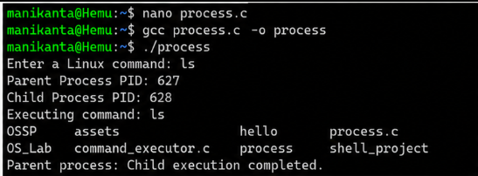

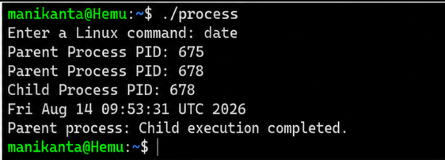

Report: I ran process.c with two commands: ls (parent PID 627, child PID 628) and date (parent PID 675, child PID 678). Both executed correctly with distinct, valid PIDs, and the parent reported completion after each. This confirms the program correctly forks and execs arbitrary user-specified commands.

- Using Linux terminal commands (uname, lscpu, lsblk, ps, top), investigate the relationship between hardware resources and operating system services. Prepare a report explaining how the OS abstracts CPU, memory, storage, and I/O devices.
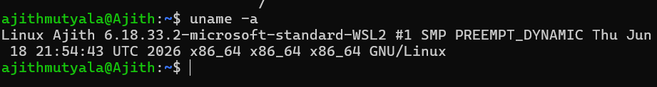

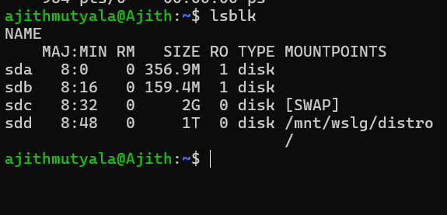

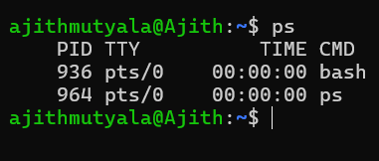
Report: I checked the system using uname -a, lsblk, and ps. uname -a confirmed the kernel (WSL2 Linux). lsblk listed disks including root (sdd, 1T) and swap (sdc, 2G). ps showed the active session's processes: bash (PID 403) and ps (PID 754). This confirms the environment inspection commands correctly reflect the running system.
